Install all the necessary tools:

* XAMP: <https://www.php.net/manual/en/install.php>

XAMP:

* Please install with these settings:  
  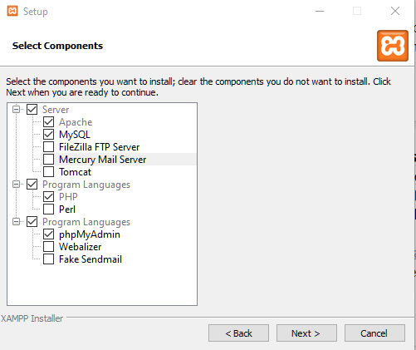

Number of Files: **10**

To load all the data files, go to the “*Datas*” folder.

* Inside the folder, it should contain **7 csv files**
  + These files should be small enough to be imported through mysql workbench using the “*Table Data Import Wizard*”
* **1 folder** named “LargeFiles”.

Inside the “LargeFiles” folder there should be…

* **2 more csv files**, which are too big to be imported via table wizard.
  + (You could try to use the table wizard, but it was too slow for me)
* **1 sql file**, called “*loadLargeFiles.sql*”

To import these large files, please copy and paste the files into the “MySQL Server 8.0/Uploads/”.

* This folder should be under this defualt path…”C:/ProgramData/MySQL/MySQL Server 8.0/Uploads/”
  + IF, it is not. Please, change the LOAD DATA INFILE path inside the SQL file named “*loadLargeFiles.sql*” to your corresponding path.
* Example:
  + *loadLargeFiles.sql*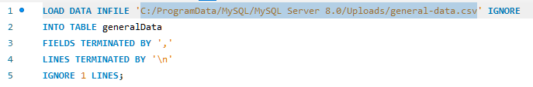
  + Folder Path  
    